Intrabeam TARGIT IORT data collection FORM
Date of operation: [Date] | NHS number: | Hospital number:

PATIENT and tumour characteristics and treatments
Last name: | First name: | Middle: |  | Birth date: Date

Tumour type  ☐ Invasive duct carcinoma (no special type)  ☐ Tubular carcinoma  ☐Cribriform carcinoma  ☐Papillary carcinoma  ☐Micropapillary carcinoma  ☐Medullary carcinoma  ☐Mucinous carcinoma  ☐Invasive lobular carcinoma  Other ___________________ | Grade  ☐ 1  ☐ 2  ☐ 3 | Pathological Tumour size  ________ (mm) | Side  ☐Left  ☐Right | Number of lymph nodes affected  ____ | ER status  ☐Positive  ☐Negative  ☐Unknown  Score  ___ /8 | PgR status  ☐Positive  ☐Negative  ☐Unknown  Score  ___ /8 | HER2neu:  ☐Positive  ☐Negative  ☐Unknown  If equivocal,  FISH/DDISH:  ______
Number of lymph nodes excised

____
Additional treatment (optional)
Re-excision? ☐ Mastectomy? ☐ Additional EBRT? ☐ Hormone therapy? ☐ Chemotherapy ☐ Bisphosphonates? ☐

Follow up information
The patient is alive and well at these follow up dates:
Follow up (6m) Date | Follow up (12m) Date | Follow up (18m) Date | Follow up (18m) Date
Follow up (24m) Date | Follow up (30m) Date | Follow up (36m) Date | Follow up (42m) Date
Follow up (48m) Date | Follow up (54m) Date | Follow up (60m) Date | Longer Follow up Date

Longer Follow up Date
Complications of treatment (if any):
Complication 1 details Date | Complication 2 details Date | Complication 3 details Date | Complication 4 details Date

Disease relapse and death (if any)
Date of local recurrence (if any) | Treatment of local recurrence | Date of distant disease (if any) | Date of death (if any) | Cause of death:
Date |  | Date | Date
Any other Notes:

Quality of life – please fill in the questionnaire between 6 months to 1 year of completion of treatment
QOL questionnaire is on the last 2 pages of this document.

This page is intentionally blank

Date of operation: [Date] | NHS number: | Hospital number:
Under each heading, please tick the ONE box that best describes your health TODAY
Date: ____ / _____ / _________

MOBILITY
I have no problems in walking about
I have slight problems in walking about
I have moderate problems in walking about
I have severe problems in walking about
I am unable to walk about

SELF-CARE
I have no problems washing or dressing myself
I have slight problems washing or dressing myself
I have moderate problems washing or dressing myself
I have severe problems washing or dressing myself
I am unable to wash or dress myself

USUAL ACTIVITIES (e.g. work, study, housework, family or leisure activities)
I have no problems doing my usual activities
I have slight problems doing my usual activities
I have moderate problems doing my usual activities
I have severe problems doing my usual activities
I am unable to do my usual activities

PAIN / DISCOMFORT
I have no pain or discomfort
I have slight pain or discomfort
I have moderate pain or discomfort
I have severe pain or discomfort
I have extreme pain or discomfort

ANXIETY / DEPRESSION
I am not anxious or depressed
I am slightly anxious or depressed
I am moderately anxious or depressed
I am severely anxious or depressed
I am extremely anxious or depressed

Date of operation: [Date] | NHS number: | Hospital number:
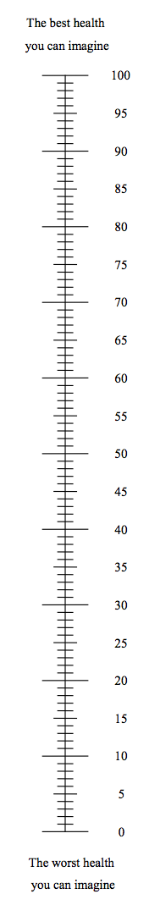
Date: ____ / _____ / _________

- We would like to know how good or bad your health is TODAY.
- This scale is numbered from 0 to 100.
100 means the best health you can imagine.
0 means the worst health you can imagine.

        - Mark an X on the scale to indicate how your health is TODAY.

- Now, please write the number you marked on the scale in the box below.

  - YOUR HEALTH TODAY =

UK (English) v.2 © 2009 EuroQol Group. EQ-5D TM is a trade mark of the EuroQol Group

